III. Procedures

The procedures of the experiment is shown clearly in Figure 1.(数字汇总的时候要改)

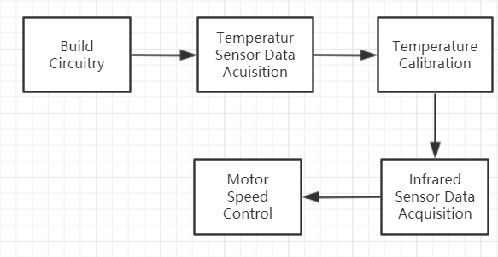

Figure 1

* 1. *Build Circuitry*

We make the circuitry on the bread board. The result is shown in Figure 2.

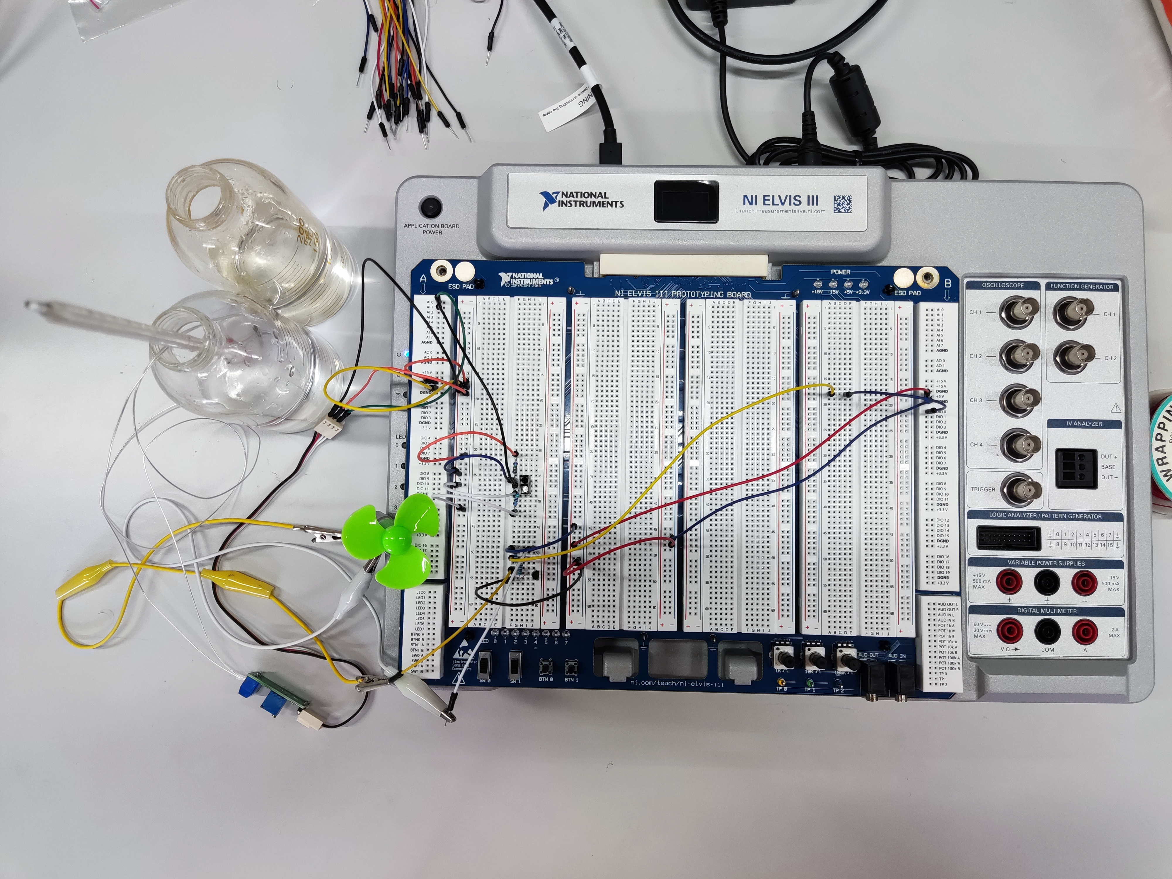

Figure 2

We divide the circuitry into two parts-- the temperature measuring one is plugged in A row of I/Os and the circuitry controlling the motor is connected with B row of I/Os in order to reduce the Reduce the influence of motor rotation on the output voltage of temperature measuring circuit.

* 1. *Temperature Sensor Data Acquisition*

In this part, we need to measure a set of temperatures of water by thermometer and their corresponding voltages on LabVIEW. The results are shown in the appendix.(交的时候附上表格)

* 1. *Temperature Calibration*

Using the data we get in last step, we draw the fitting curve and get the relationship between voltage and temperature. The result is shown in Figure 3.

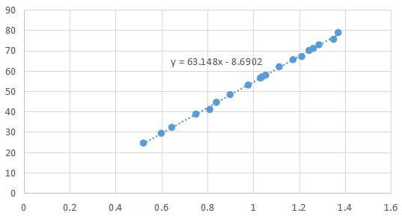

Figure 3

Depend on this equation, we write the program as Figure 4.

测温程序截图

Figure 4

After then, the resistance temperature detector can show the correct temperature on VI directly.

* 1. *Infrared Sensor Data Acquisition*

In this part, we measure the output of infrared sensor with human and without human conditions respectively. If we block the infrared sensor, which means the sensor detect someone here, the output is about 0.2. And if there is no people, the output of sensor is around 0.4. So we set the judge criteria as 0.3. If the output of the sensor is larger than 0.3, it recognizes the presence of human being.

* 1. *Motor Speed Control*

Based on different inspection situations, we use different control strategies to control the motor speed. The program is shown in Figure 5.

控制转速程序截图

Figure 5

If the infrared sensor detects the presence of human, the motor rotate in maximum speed regardless of the temperature. If there is no people beside the infrared sensor, the motor speed changes with the reading of temperature sensor--the motor starts to work at 33 ℃ and reaches the maximum speed at 45 ℃.